
City of Twin Falls
Building Department
203 Main Ave. E.
P.O. Box 1907
Twin Falls, ID 83303-1907
Phone: 208-735-7238
Fax: 208-736-2256
www.tfid.org
Replacement & New Window Requirements

Section 308, 310, & 312 of the 2018 International Residential Code
When do I need a permit for windows?
- When enlarging or reducing size of window opening.
- When installing a NEW window of any size. (not a replacement window)
- When replacing windows in a room where wall finishes (sheetrock or plaster) have been removed. At least one window in each bedroom will need to meet current egress requirements.
What will I need to submit for a building permit?
- Floor plan (to scale) showing rooms on floor(s) where work is happening. Drawn in CAD or on graph paper.
- All rooms to be labeled & specify new or existing. This is important to know for bedrooms. ***If new bedroom is not currently recognized as a bedroom on county tax appraisal, exterior wall in bedroom will be required to be insulated to R-11 min, & room to be wired to NEC code***
- Show header sizes over windows. Header may not be needed in basements if there is a concrete lintel above opening.
- Specify window type and size. A minimum net clear opening area of 5 sq. feet on main floor and basement & 5.7 sq. feet for other floors/levels.
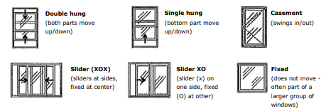
- Specify height to opening of window. Cannot be over 44” from finished floor for egress window.
- Show window well in basements. Specify depth from wall, depth out of window well, and show fixed ladder or stairs if greater than 44” out of window well.
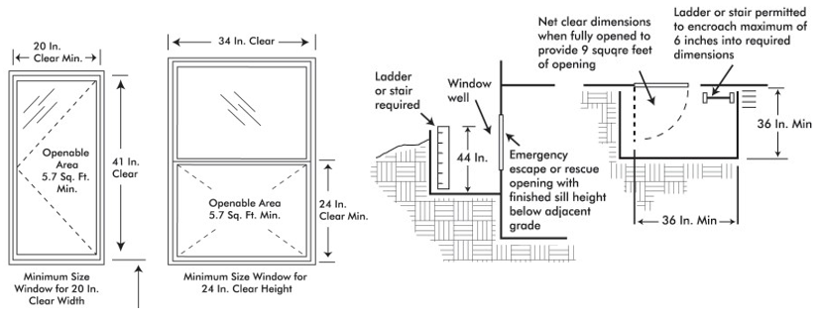
- Specify ceiling height of room where window will be located. ***Ceiling height 6’-8” min. for habitable space in existing residences or 7’-0” in new homes***
- Show any doors located next to doors. Any door within 24” arc of a door to be safety glazed.
- Show any windows that are safety glazed. Glazing required if all 4 conditions are met: If <18” from floor, over 9 sq. ft. pane of glass, top edge is >36” above floor, and walking surface is within 36” of glazing.
- Show smoke alarms & carbon monoxide detectors.

• Windows installed without a permit may need to be removed and replaced with appropriate windows. In addition, fees are doubled for work performed without permit.
• These guidelines do not apply to properties listed in designated historic districts - contact the Historic Preservation Planner at (208) 735-7269 for more information.
• New windows must also meet 2018 IECC energy efficiency guidelines (.35 u value minimum).
• To get a building permit to replace windows, go to www.tfid.org for online submittals or come to the Twin Falls City Hall at 203 Main Ave. E. Twin Falls, ID 83301. If you need more information, please call (208) 735-7238.
• See https://www.tfid.org/DocumentCenter/View/4451/2020-Residential-Remodel-Appicaton-fillable-Sept-2020?bidId= for application and full submittal requirements for permit.

